**Advantage of Micro-services**

1. Easy to maintain
2. Easy to update one or more module without affecting to another module
3. If one module goes down, then it will not affect to another module.

There are 2 types of OS:- Guest OS and Host OS

**Docker:-**

Is as tool designed to make it easier to create, deploy, and run applications by using containers.

Docker containers are lightweight alternatives to VM and it uses the host OS.

You don’t have to pre-allocate any RAM or any Disk in containers.

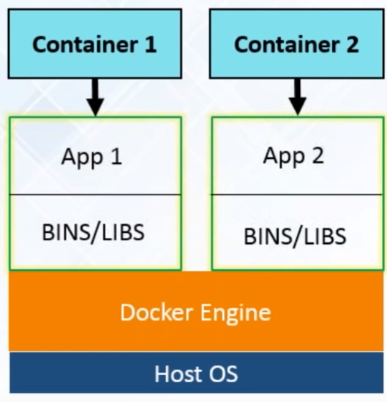

**Work Flow of Docker:-**

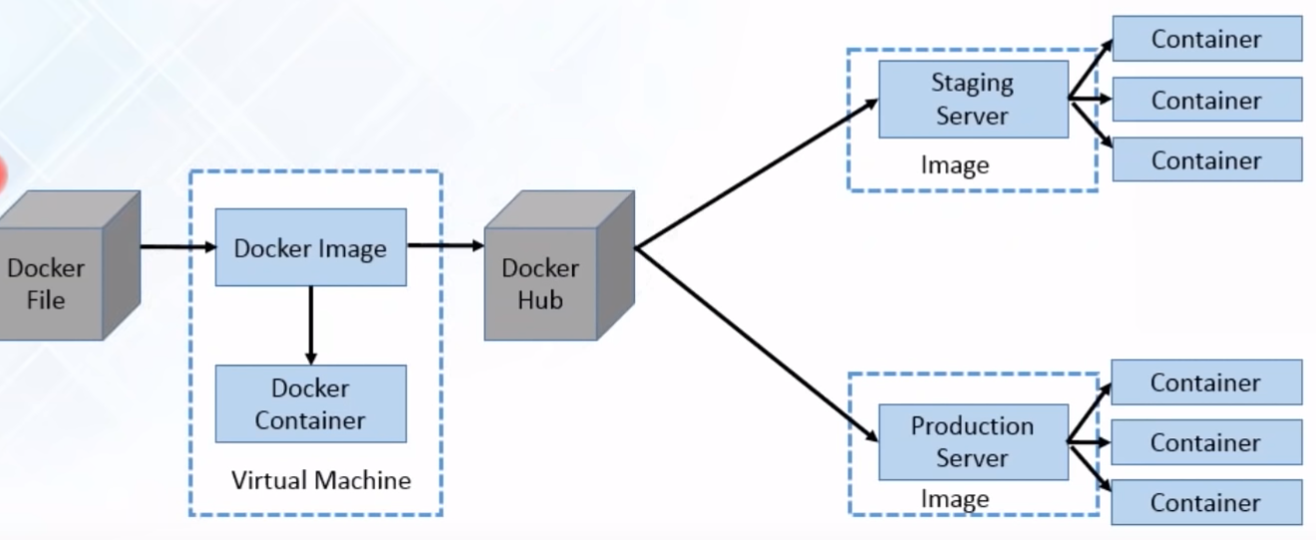

Developer write code that define an application requirement and dependency in an easy to write Docker file.

Docker file build a Docker image and that image contains all the project’s code and project requirement.

You can run that Docker image to create as many Docker containers as you want.

Docker Container are the run time instance of Docker Image.

Docker Image is uploaded to Docker Hub.

Docker Hub is git repository for Docker Images. It contain public and private repository.

From Docker Hub, different team will pull images and prepare their environment.

Now we have same requirement available throughout the SDLC.

**Docker Component:-**

**Docker Registry:-**

It is a storage component for Docker Images.

We can store the Images in either public/private repositories.

Docker Hub is Docker’s ver own cloud repository.

**Why use Docker Registries:-**

Control where your images are being stored.

Integrate image storage with your in-house development workflow.

**Docker Images & Containers:-**

Docker Images are read only Template used to create Containers

Docker image contain all the dependency for a particular application or microservice.

Built by Docker Users (User can create their own Image also or can pull from git)

Stored in Docker Hub or your local Registry

Docker Containers are run time instance of Docker Images.

It contain everything that require to run an application or microservice.

At the same time, it is also possible that more than one Docker Image require to create Docker container.

**Install Docker in Ubuntu:-**

Update all packages

Sudo apt-get update

Install pre-requestic

Sudo apt-get install linux-image-extra-$(uname –r) linux-image-extra-virtual

Install Docker

Sudo apt-get install docker-engine

Start Docker Service

Sudo service docker start

Pull Centos Docker image in Ubuntu (Below command first will check Centos image in local, If it doesn’t find then it will go to DockerHub for Centos Image and it will pull image from there.)

Sudo docker pull centos

Run Centos Container (After running below command we will be in Centos Container)

Sudo docker run –it centos

**Docker Compose:-**

Docker Compose make it easier to configure and run applications made up of multiple containers. Example:- Having 3 containers – One running a web app, one running Postgres, one running redis. All in one YAML file and then running those three connected containers with single command.

